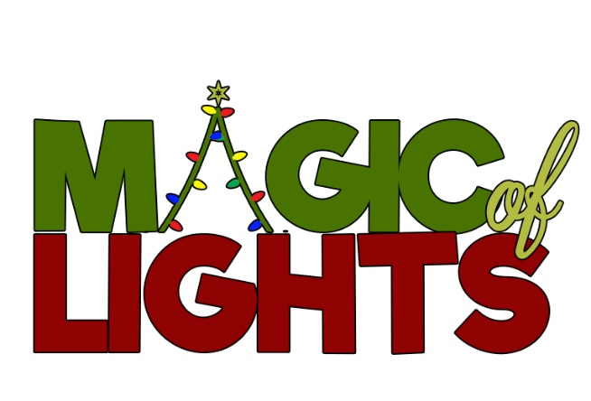

Magic of Lights is a dazzling outdoor holiday lights drive-through display. The safety of our guests is our top priority; therefore, guests can experience brilliant holiday lights in the safety of their own car.
- Magic of Lights will continue to offer, and encourages, contactless ticketing by allowing customers to purchase tickets in advance by going online
- Upon arrival, guests remain in the comfort and safety of their vehicles
- Magic of Lights asks that all guests remain within their vehicle throughout the ride.
- Guests may exit their vehicles inside THE NORTH POLE for ONLY comfort Station usage and to pick up Pre Ordered Concession items.
  - Guests must return to their vehicles once they have finished at the Comfort Stations and or picked up their Pre Ordered Concession items.
- Any items of food or drink brought or purchased by the guest must remain in the vehicle.
- Guests must continue to adhere to local guidelines in maintaining social distancing and wearing Face masks at all time when outside of their vehicles. Comfort Stations and Concession areas only.
Please practice social distancing (minimum six-feet separation between others) if necessary, to leave your vehicle.
- Magic of Lights will enhance cleaning and sanitation wherever necessary.

Magic of Lights will continue to post updates as necessary on www.magicoflights.com

